Getting Started with Apache Camel and Spring Boot

Step 1: Getting Started with Apache Camel and Enterprise Integration:

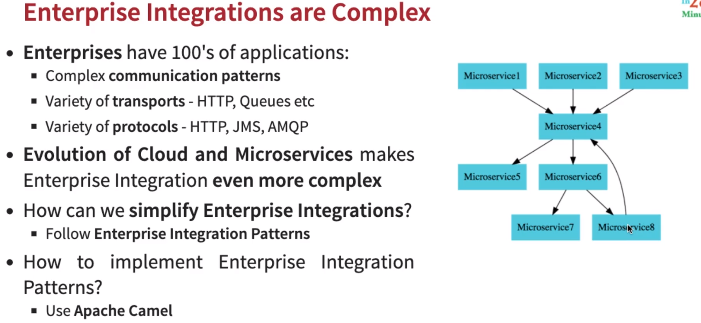
Enterprisers Integration are every complex. When taking about Enterprisers, they have hundreds of applications, if not thousands of applications. There apps have complex communication patterns and they use variety of transport, HTTP, Queue ect… and variety of protocols.
Also the evolution of cloud and micro-services makes enterprise integrations even more complex.
